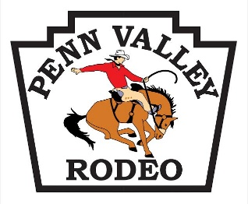
61st Anniversary Penn Valley Rodeo Sponsorship Opportunities (2018)

The Gold Buckle (Exclusive – One only) $8,000

- NAME & LOGO ON POSTERS & T-SHIRT SLEEVES
- NAME & LOGO ON ROAD BANNERS
- LOGO FLAG PRESENTED BY MOUNTED RIDER IN GRAND ENTRY
- LOGO FLAG PRESENTED BY MOUNTED RIDER IN THE RODEO PARADE
- BANNERS AT ENTRY GATES
- TWO BANNERS IN ARENA
- FULL PAGE AD BACK COVER OF PROGRAM
- NAMED AS PRESENTING SPONSOR IN ALL RADIO AND PRINT ADS
- COMPANY NAME ANNOUNCED 5+ TIMES PER SHOW
- BANNER DISPLAYED FOR SEASON
- FEATURED ON WWW.PVRODEO.COM
- FEATURED ON FACEBOOK AND TWITTER
- FEATURED IN OUR MONTHLY MEMBER NEWS LETTER
- FEATURED AT THE RODEO KICK OFF MIXER
- 20 COMPLIMENTARY RODEO TICKETS
- 4 TICKETS TO THE SPONSOR APPRECIATION TENT

61st Anniversary Penn Valley Rodeo Sponsorship Opportunities (2018)

The Silver Spur $3,000.00

- NAME AND LOGO ON POSTERS
- LOGO FLAG PRESENTED BY MOUNTED RIDER IN GRAND ENTRY
- LOGO FLAG PRESENTED BY MOUNTED RIDER IN THE RODEO PARADE
- TWO BANNERS IN ARENA
- 1/2 PAGE AD IN PROGRAM
- NAMED AS MAJOR SPONSOR IN ALL RADIO AND PRINT ADS
- COMPANY NAME ANNOUNCED 3+ TIMES PER SHOW
- FEATURED ON WWW.PVRODEO.COM
- FEATURED ON FACEBOOK AND TWITTER
- FEATURED IN OUR MONTHLY MEMBER NEWS LETTER
- FEATURED AT THE RODEO KICK OFF MIXER
- 12 COMPLIMENTARY TICKETS
- 4 TICKETS TO THE SPONSOR APPRECIATION TENT

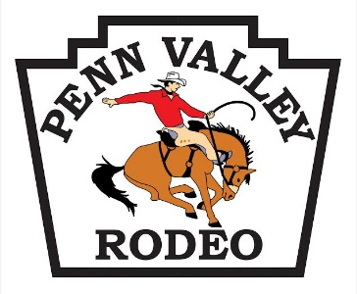
61st Anniversary Penn Valley Rodeo Sponsorship Opportunities

STAGE SPONSOR (exclusive – one only) $3,000.00

- BACKDROP GRAPHICS COVERS BACK WALL OF STAGE *
- NAME BANNER USED AS STAGE TITLE
- LOGO FLAG PRESENTED BY MOUNTED RIDER IN GRAND ENTRY
- LOGO FLAG PRESENTED BY MOUNTED RIDER IN RODEO PARADE
- COMPANY NAME ANNOUNCED 3+ TIMES PER SHOW
- 1/2 PAGE AD IN PROGRAM
- FEATURED ON WWW.PVRODEO.COM
- FEATURED ON FACEBOOK AND TWITTER
- 12 COMPLIMENTARY TICKETS
- NAME BANNER DISPLAYED FOR SEASON
- 4 TICKETS TO THE SPONSOR APPRECIATION TENT

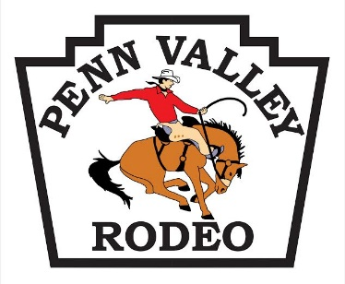
61st Anniversary Penn Valley Rodeo Sponsorship Opportunities

TICKET SPONSOR (exclusive – one only) $1,100.00 SOLD

- COMPANY LOGO AND ADVERTISING PRINTED ON TICKETS
- ¼ PAGE AD IN PROGRAM
- FEATURED ON WWW.PVRODEO.COM
- FEATURED ON FACEBOOK AND TWITTER
- FEATURED IN THE MONTHLY MEMBER NEWSLETTER
- ANNOUNCEMENT 2+ TIMES PER SHOW
- 8 COMPLIMENTARY TICKETS
- 4 TICKETS TO THE SPONSOR APPRECIATION TENT

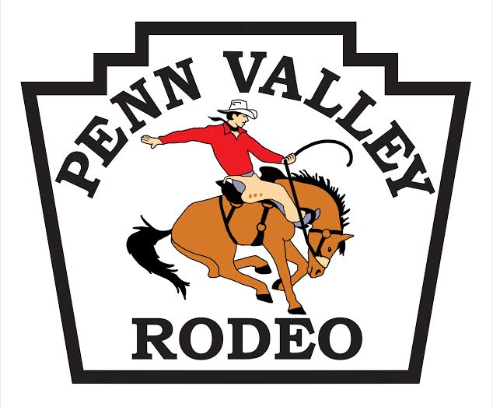
61st Anniversary Penn Valley Rodeo Sponsorship Opportunities

The Bucking Chute (Only 5) $850.00

- COMPANY BANNER MOUNTED ON CHUTE GATE- *
- YOUR COMPANY ANNOUNCED EVERY TIME THE GATE OPENS
- FEATURED ON WWW.PVRODEO.COM
- FEATURED ON FACEBOOK AND TWITTER
- FEATURED IN THE MONTHLY MEMBER NEWSLETTER
- BUSINESS CARD AD IN THE PROGRAM
- 6 COMPLIMENTARY TICKETS
- 4 TICKETS TO THE SPONSOR APPRECIATION TENT

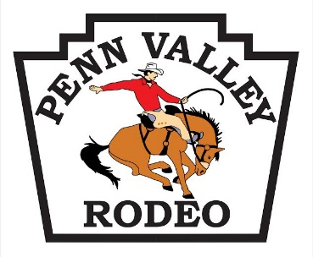
61st Anniversary Penn Valley Rodeo Sponsorship Opportunities

The Flag (only 8) $500.00
EVENT FLAG SPONSOR

- LOGO FLAG PRESENTED BY MOUNTED RIDER IN GRAND ENTRY
- LOGO FLAG PRESENTED BY MOUNTED RIDER PRIOR TO AN EVENT
- COMPANY NAME ANNOUNCED AS RIDER CIRCLES ARENA.
- FEATURED ON WWW.PVRODEO.COM
- FEATURED ON FACEBOOK AND TWITTER
- FEATURED IN THE MONTHLY MEMBER NEWSLETTER
- FLAG ON DISPLAY PRIOR TO RODEO
- 4 COMPLIMENTARY TICKETS
- 2 TICKETS TO THE SPONSOR APPRECIATION TENT

61st Anniversary Penn Valley Rodeo Queen Sponsorship Opportunities (2018)

The Black Hat $400.00
ARENA BANNER SPONSOR
  - 2 BANNERS DISPLAYED INSIDE ARENA FENCE OR ON ARENA SEATING RAILS
  - OPTIONAL: Summer Series $100.00 Additional
  - Banner also Displayed at 4 GYMKHANAS, 4 BARREL RACES plus THE MULE SHOW
  - LOGO ON POSTERS AND FLYERS FOR MULE SHOW
  - (Sponsor pays for 2 banners 8’ L X 24” H)

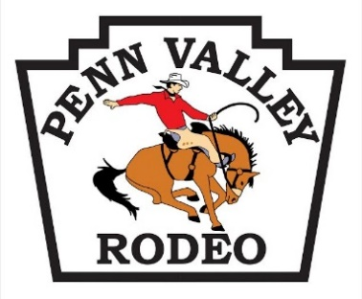

61st Anniversary Penn Valley Rodeo Sponsorship Opportunities (2018)

Muttin Bustin (only 1) $600.00

- COMPANY ANNOUNCED DURING THE EVENT EACH DAY
- LOGO FLAG PRESENTED BY MOUNTED RIDER PRIOR TO EVENT
- SPONSOR PRESENTS BUCKLE TO WINNER
- PHOTO OPPORTUNITY
- FEATURED ON WWW.PVRODEO.COM
- FEATURED OF FACEBOOK AND TWITTER
- FEATURED IN MONTHLY MEMBER NEWSLETTER
- 4 COMPLIMENTARY TICKETS
- 4 TICKETS TO THE SPONSOR APPRECIATION TENT

61st Anniversary Penn Valley Rodeo Sponsorship Opportunities (2018)

Calf Scramble (Only 1) $200.00

  - COMPANY ANNOUNCED DURING THE EVENT EACH DAY
  - LOGO FLAG PRESENTED BY MOUNTED RIDER PRIOR TO EVENT (Sponsor provides flag)
  - SPONSOR PRESENTS AWARD
  - PHOTO OPPORTUNITY
  - FEATURED ON WWW.PVRODEO.COM
  - FFEATURED ON FACEBOOK AND TWITTER
  - FEATURED IN THE MONTHLY MEMBER NEWSLETTER
  - 4 COMPLIMENTARY TICKETS
  - 2 TICKETS TO THE SPONSOR APPRECIATION TENT

61st Anniversary Penn Valley Rodeo Queen Sponsorship Opportunities (2018)

The Raw Hide $50 - $100

- 8X10 FLYER MOUNTED ON A DOUBLE SIDED SANDWHICH BOARD AND PROMINENTLY DISLAYED AT VARIOUS LOCATIONS THROUGHOUT THE RODEO GROUNDS
- SPONSOR PROVIDES THE FLYERS
- $50 FOR THE RODEO WEEKEND, $100 FOR BOTH RODEO AND MULE SHOW

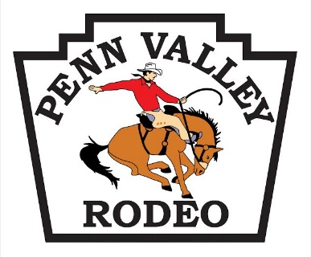
61st Anniversary Penn Valley Rodeo Sponsorship Opportunities (2018)

Fast is Fun Barrel Sponsor (Only 3) $200 EA OR $600 FOR ALL

- COMPANY NAME AND LOGO ON BARREL SLEEVES
- BARRELS WILL BE FEATURED IN BARREL RACING AT THE RODEO AND AT THE DOC HALSTEAD MEMORIAL BARREL RACES PLUS THE MULE AND DONKEY SHOW.
- SPONSOR TO PROVIDE SLEEVES
- SPONSOR’S NAME WILL BE ANNOUNCED PRIOR TO BARREL RACING EVENTS
- FEATURED ON WWW.PVRODEO.COM
- FEATURED ON FACEBOOK AND TWITTER
- FEATURED IN THE MONTHLY MEMBER NEWSLETTER
- 4 COMPLIMENTARY TICKETS
- 2 TICKETS TO THE SPONSOR APPRECIATION TENT

61st Anniversary Penn Valley Rodeo Queen Sponsorship Opportunities (2018)

PROGRAM ADVERTISING
- • Inside Front or Back Cover, color $ 800.00
- 4 Tickets to the Sponsor VIP Tent at the Rodeo
- • Full Page AD $ 650.00
- 2 Tickets to the Sponsor VIP Tent at the Rodeo
- • ½ PAGE AD $ 325.00
- • ¼ PAGE AD $ 165.00
- • Business card AD $ 65.00

- Print Ready Ads are required in .JPG, PDF or .GIF format or clear, scan-able print by:
Fri. 3/23
- Programs will be out to local businesses and ticket sales locations approximately 1 month prior to the Rodeo

We sincerely hope that you will see the great value in sponsoring The Penn Valley Community Rodeo this year and every year thereafter!

61st Anniversary Penn Valley Rodeo Sponsorship Opportunities (2018)

Arena Tractor Sponsor (Only 1) $600

- COMPANY NAME AND LOGO ON A BILLBOARD ON THE ARENA TRACTOR USED TO PREPARE THE ARENA AND TO DRAG ARENA PRIOR TO EVENTS AS NEEDED
- TRACTOR WILL BE ON DISPLAY IN THE VENDOR AREA WHEN NOT IN USE
- SPONSOR WILL BE PROVIDED A VENDOR SPACE ALSO
- 4 COMPLIMENTARY TICKETS
- 2 TICKETS TO THE SPONSOR APPRECIATION TENT

61st Anniversary Penn Valley Rodeo Sponsorship Opportunities (2018)

Children’s Rodeo Coloring Contest Sponsor (Only 1) $200

- SPONSORS NAME AND LOGO ON THE COLORING SHEETS DELIVERED TO LOCAL SCHOOLS PRIOR TO THE RODEO.
- COMPLETED ART WILL BE POSTED AT THE RODEO GROUNDS DURING THE RODEO
- PHOTO OPPORTUNITY WITH CONTEST WINNERS
- FEATURED ON WWW.PVRODEO.COM
- FEATURED ON FACEBOOK AND TWITTER
- FEATURED IN THE MONTHLY MEMBER NEWSLETTER
- 2 COMPLIMENTARY TICKETS
- 2 TICKETS TO THE SPONSOR APPRECIATION TENT

